

**School Travel Plan Policy**

Wormholt Park Primary School

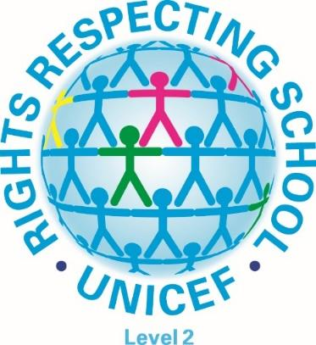

**Article 29**

**The education of the child shall be directed to the development of the child’s personality, talents and mental and physical abilities to their fullest potential. It also helps the child to learn to live peacefully, protect the environment and respect other people.**

|  |  |
| --- | --- |
| Heads Signature |  |
| Date | Summer 2022 |
| Reviewed: |  |
| Next Review Date: | Summer 2023 |

At Wormholt Park Primary School, we encourage pupils and parents to travel to school by cycling, scooting and walking wherever possible.

This school travel policy explains how we encourage active travel to school. We will discuss the policy with the pupils and re-visit it periodically to ensure its relevance. For pupils unable to come by foot or bike, we encourage the use of public transport.

**Some of the benefits of active travel:**

1. Improving both mental and physical health
2. Improving physical health, helping pupils to achieve the recommended minimum of 60 minutes of physical activity per day
3. Establishing positive active travel behaviour.
4. Promoting independence and improving safety awareness.
5. Reducing congestion, noise and pollution in the community.
6. Reducing the environmental impact of the journey to school
7. Improving the air quality around school

**To encourage pupils to cycle, scoot or walk to school frequently the school will:**

1. Actively promote cycling, scooting and walking as a positive way of travelling through running special themed active travel days and weeks
2. Celebrate the achievements of those who cycle, scoot and walk to school
3. Provide cycle and scooter storage on the school site (parents must supply their own lock)
4. Arrange Bikeability training for pupils in Year 5 and 6 every year
5. Arrange Scooterability training for pupils in Year 1
6. Regular scooter / bike sessions embedded in PE lessons to teach basic skills to enable young children use bikes and scooters more in Reception and Nursery
7. Work with our borough school travel advisor and road safety officers to deliver activities and assemblies that promote active, safe and responsible travel to school
8. Run bike and scooter maintenance sessions with our local Dr. Bike team

**To make cycling, scooting and walking to and from school a positive experience for everybody concerned, we expect our pupils to:**

1. Ride and walk sensibly and safely and to follow the Highway Code and Green Cross Code. We will provide assemblies on this as a reminder for all children.
2. Check that their bicycle or scooter is roadworthy and regularly maintained.
3. Behave responsibly as a pupil of Wormholt Park Primary School, and to consider the needs of others when cycling or scooting.
4. Encourage the use of a cycle helmet to be worn at all times when cycling to and from school.
5. Ensure they can be seen by other road users, by using lights and wearing high-visibility clothing, as appropriate.

**For the well-being of our pupils, we expect parents and carers to:**

1. Encourage their child to walk, cycle or scoot to school whenever possible.
2. Encourage their child to take up opportunities to develop their competence and confidence in cycling or scooting.
3. Consider cycling, scooting and walking with their child on the school run; possibly joining with other families as a ‘cycle train’.
4. Provide their child with equipment such as high-visibility clothing, lights, a lock and cycle helmet as appropriate.
5. Ensure that the bicycles and scooters ridden to school are roadworthy and regularly maintained.

**Please note: The decision as to whether a child is competent to cycle, scoot or walk safely to and from school rests with the parent(s)/carer(s). The school has no liability for any consequences of that decision. Parents are advised to take out appropriate insurance cover for bikes (check home insurance) as the school’s insurance does not cover any loss or damage to bicycles and scooters.**

It also supports our Rights Respecting School Status and the values of the UNCRC, Article 29 which states:

The education of the child shall be directed to the development of the child’s personality, talents and mental and physical abilities to their fullest potential.

It also helps the child to learn to live peacefully, protect the environment and respect other people.